David John Brown
June 13, 1968 – June 28, 1968

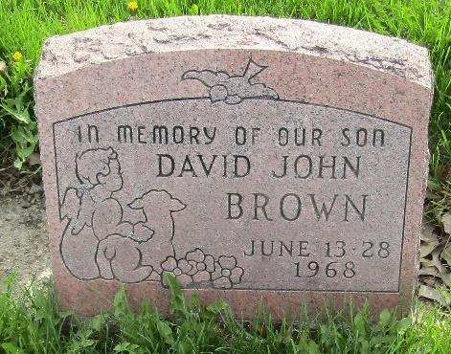
Photo by Colleen Sanders

David John Brown
in the Indiana, U.S., Death Certificates, 1899-2017
Name David John Brown
Gender Male
Race White
Marital Status Never Married (Single)
Age 15 days
Birth Date 13 Jun 1968
Birth Place Indiana
Death Date 28 Jun 1968
Death Place Bluffton, Wells, Indiana, USA
Death Registration Date 1968
Father David Glen Brown
Mother Shirley Young
Informant David Brown; father; Bluffton, Indiana
Burial June 29, 1968; Murray Cemetery; Murray, Indiana

