Benjamin C. Brown
March 23, 1869 – February 7, 1954

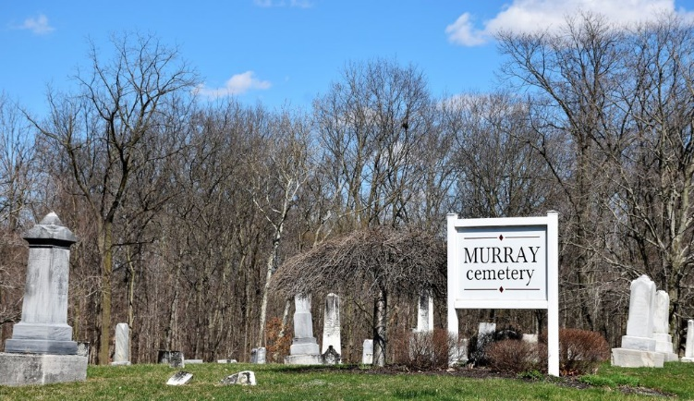
Photo by Colleen Sanders

Benjamine C Brown
in the Indiana, U.S., Death Certificates, 1899-2017
Name Benjamine C Brown
Gender Male
Race White
Marital Status Married
Age 84
Birth Date 23 Mar 1869
Birth Place Indiana
Death Date 7 Feb 1954
Death Place Bluffton, Wells, Indiana, USA
Death Registration Date 1954
Father John Brown
Mother Leutisha Agler
Informant Mrs. Pearl Brown; Bluffton, Indiana
Burial February 9, 1954; Murray Cemetery; Wells County, Indiana

