Miranda (Sutton) Braner
February 14, 1856 – December 2, 1891

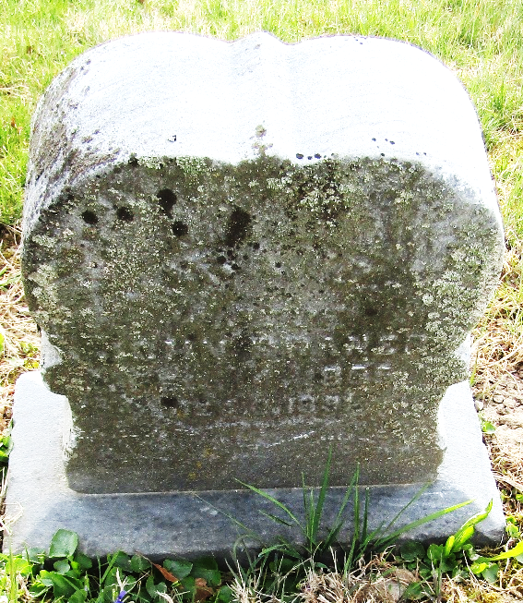

Miranda Braner from tree Brenner Family Tree
Birth 14 Feb 1856 Wells, Indiana, USA
Marriage 20 Aug 1874 Wells, York, Maine, USA
Residence 1880 Bartholomew, Indiana, USA
Death 2 Dec 1891 Wells, Indiana, USA
Father Oscar Fitzallen Sutton (1822-1903)
Mother Margret J Sutton (1830-1871)
Spouse John Brenner

