Grace D. (Wibel) Bracht
May 4, 1889 – May 4, 1960

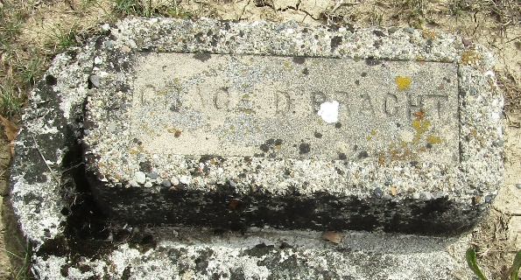

Grace D Bracht
in the Indiana, U.S., Death Certificates, 1899-2017
Name Grace D Bracht
[Grace D Wibel]
Gender Female
Race White
Marital Status Widowed
Age 71
Birth Date 4 May 1889
Birth Place Indiana
Death Date 4 May 1960
Death Place Columbia City, Whitley, Indiana, USA
Death Registration Date 1960
Father Marion Wibel
Mother Mary Ann Kissinger
Informant Mrs. Louise Farris; Columbia City, Whitley County; no relation
Burial May 6, 1960; Murray Cemetery; Wells County, Indiana

