Oris H. Bowman
October 12, 1876 – December 30, 1876

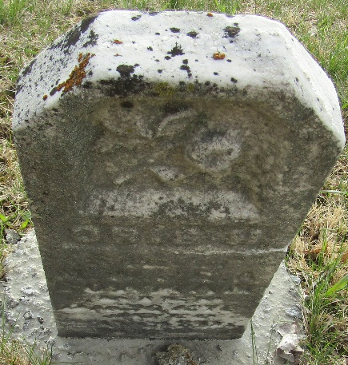

Oris H Bowman from tree Reed_2010-09-11
Birth 12 Oct 1876 Indiana, USA
Death 30 Dec 1876 Indiana, USA
Father Mathias W. Bowman (1843-1895)
Mother Elizabeth Ann Bowman (1840-19

