Mathias Walter Bowman
February 21, 1843 – November 23, 1895

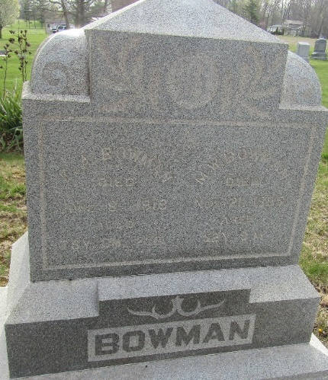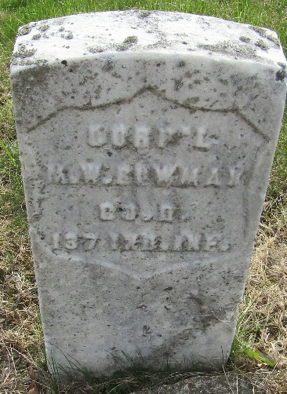

W. M. Bowman
in the Indiana, U.S., WPA Death Index, 1882-1920
Name W. M. Bowman
Date Nov 23, 1895
Location Wells County
Age 52 Yr
Gender Male
Race White
Source location County Health Office, Bluffton
Source notes The source of this record is the book H-14 on page 114 within the series produced by the Indiana Works Progress Administration.
**
Mathias Walter Bowman from tree BENTLEY
Birth 21 Feb 1843 Columbiana, Columbiana, Ohio, USA
Marriage 23 Dec 1874 Miami, Indiana, USA
Residence 1880 Huntington, Indiana, USA
Death 23 Nov 1895 Allen, Indiana, USA
Father Henry Bowman (1815-1891)
Mother Harriet Jane Armstrong (1815-1894)
Spouse Elisabeth Wilkerson (1840-1900)

