Elizabeth Ann (Wilkerson) Bowman
February 14, 1840 – June 8, 1918

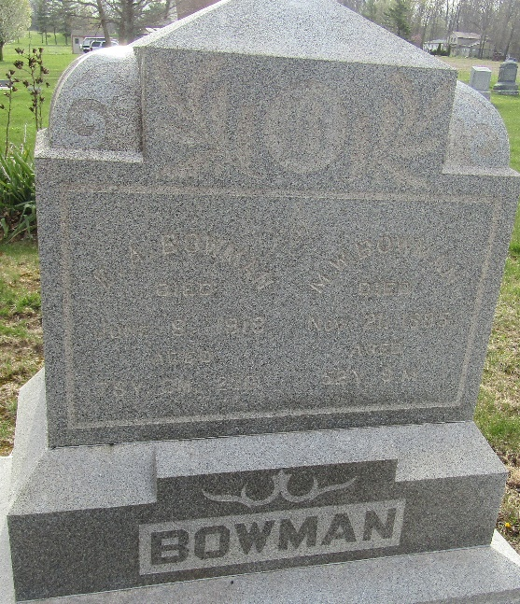

Elizabeth Ann Bourman
in the Indiana, U.S., Death Certificates, 1899-2017
Name Elizabeth Ann Bowman
Gender Female
Race White
Marital Status Widow
Age 78 years, 3 months, 23 days
Birth Date 15 Feb 1918 [sic]
Birth Place Clinton County, Ohio
Death Date 8 Jun 1918
Death Place Chester, Wells, Indiana, USA
Death Registration Date 1918
Father Thomas Wilkerson
Mother Nancy Lawrence
Spouse Mathias Walter Bowman
Informant Family; Poneto, Indiana
Burial June 10, 1918; Murray Cemetery

