Uriah Clement Blue
August 18, 1808 – October 16, 1867

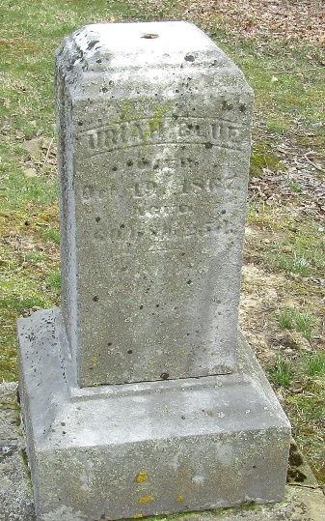

Uriah Clement Blue from tree DEEDS Family Tree
Birth 18 Aug 1808 Ohio, USA
Marriage 31 Aug 1838 Allegany, Maryland, USA
Residence 1870 Concord, Champaign, Ohio, USA
Death 16 Oct 1867 Wells, Indiana, USA
Father Michael M Blue (1775-1854)
Mother Catherine Eaton Lennon (1782-1869)
Spouse Rachel Moore (1807-1877)

