Rachael (Moore) Blue
March 1, 1807 – February 6, 1877

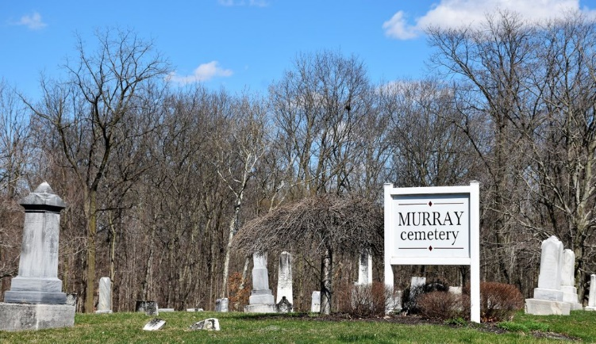
Photo by Colleen Sanders

Rachael Moore from tree McDavid/Tweed Family Tree.
Birth 1808 Ohio, USA
Marriage 1828 Ohio, USA
Residence 1870 Wells, Indiana, USA
Death 6 Feb 1877
Spouse Uriah Clement Blue (1807-1867)

