Mary Elizabeth (Myers) Blue
August 15, 1842 – March 22, 1873

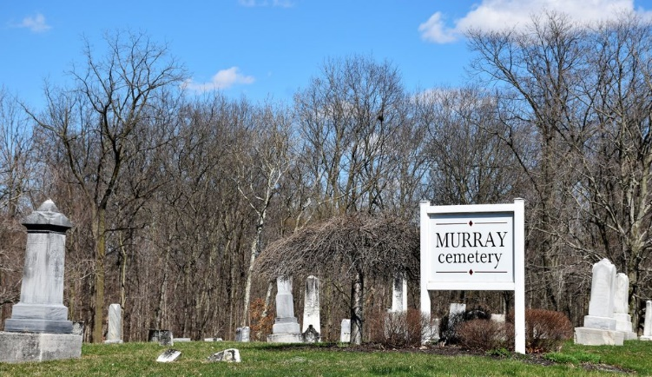
Photo by Colleen Sanders

Mary Elizabeth Myers from Myers Family Tree
Spouse James Arthur Blue
Father Jacob Myers
Mother Martha DeHaven
Children Lucy E.
Birth 15 Aug 1842 Streetsboro, Portage, Ohio, USA
Death 22 Mar 1873 Wells, Indiana, USA
Residence 1870 Bluffton, Wells, Indiana, USA

