John Blue
1850 - 1876

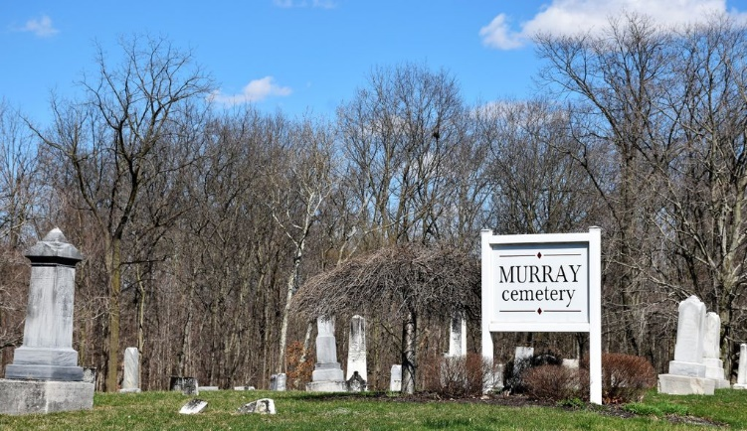
Photo by Colleen Sanders

John Blue from tree Simons-Smith Family Tree
Birth 1850 Indiana, USA
Residence 1870 Wells, Indiana, USA
Death 1876
Father Uriah Clement Bilyeu (1807-1882)
Mother Rachel Moore (1808-1877)

