Frances S. (Shady) Blosser
May 9, 1862 – May 10, 1901

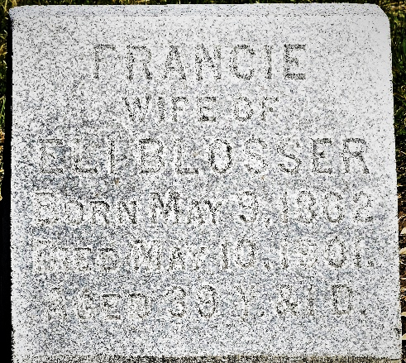
Photo by Colleen Sanders

Mrs. Eli Blosser died last night at eleven o'clock at her home on the Harmon Frees Farm north of Murray. She was ill for six days with inflammatory rheumatism, which became complicated with heart trouble, and she died three hours after being seized with the latter.
Mrs. Blosser was 39 years old.
A daughter of the late William Shady and leaves a husband and two children.
The funeral occurs on Monday at nine o'clock at Murray.

Unknown source

**
Indiana, U.S., Death Certificates, 1899-2017
Name Frances Shady Blosser
Marital Status Married
Age 39 years, 1 day
Birth Date abt 1862
Birth Place Wells County, Indiana
Death Date 10 May 1901
Death Place Murray, Wells, Indiana, USA
Death Registration Date 1901
Father William Shady
Mother Hanna M Jones
Informant Herman Thoma; Bluffton, Indiana
Burial May 13, 1901; Murray Cemetery; Wells County

