Maria J. Black
February 4, 1851 – July 4, 1891

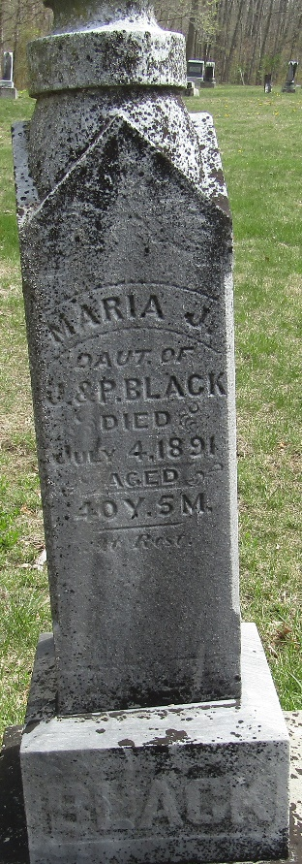

Maria Black
in the Indiana, U.S., WPA Death Index, 1882-1920
Name Maria Black
Date Jul 04, 1891
Location Wells County
Age 37 Yr
Gender Female
Race White
Source location County Health Office, Bluffton
Source notes The source of this record is the book H-14 on page 30 within the series produced by the Indiana Works Progress Administration.

