Rebecca J. (Nelson) Biddle
May 28, 1839 – January 28, 1903

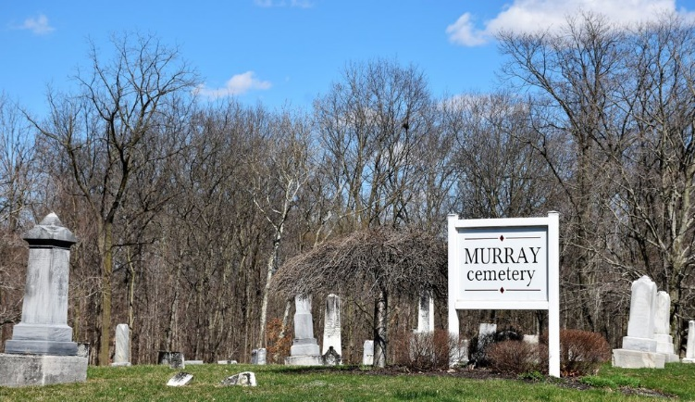
Photo by Colleen Sanders

Reledia J Biddle
in the Indiana, U.S., Death Certificates, 1899-2017
Name Rebeka J Biddle
[Rebeka J Nelson]
Gender Female
Race White
Marital Status Widowed
Age 63
Birth Date 28 May 1839
Birth Place Ohio Stark County
Death Date 28 Jan 1903
Death Place Lancaster, Wells, Indiana, USA
Death Registration Date 1903
Father James Nelson
Mother Sarah Beals
Spouse Alex Biddle
Informant Jones/James? Nelson; Bluffton, Indiana
Burial January 30, 1903; Murray Cemetery

