Lewis Alexander Biddle
March 27, 1887 – April 8, 1888

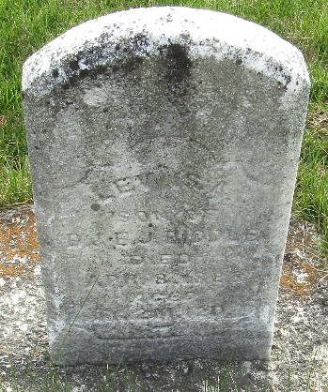

Lewis Alexander Biddle in Manton Area Family Tree Project
Father Daniel Biddle
Mother Emma Jane Garton
Birth 27 Mar 1887 Ossian, Wells, Indiana, USA
Death 8 Apr 1888 Ossian, Wells, Indiana, USA

