Daniel C. Biddle
1884 – September 14, 1884

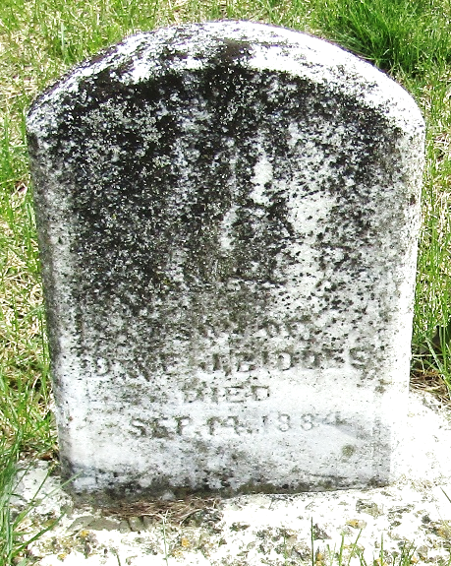

Daniel C Biddle from tree Manton Area Family Tree Project
Birth 1884 Ossian, Wells, Indiana, USA
Death 14 Sep 1884 Ossian, Wells, Indiana, USA
Father Daniel Biddle (1860-1931)
Mother Emma Jane Garton (1861-1930)

