Wilford M. Bender
October 3, 1863 – March 31, 1903

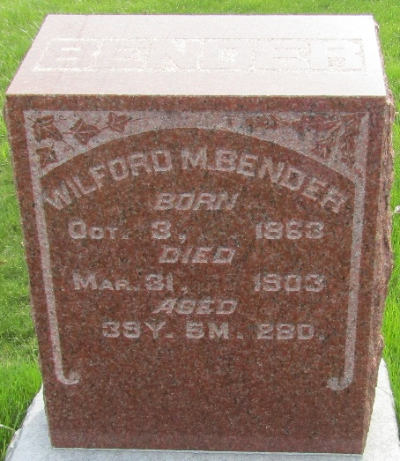

Wilford Beuder
in the Indiana, U.S., Death Certificates, 1899-2017
Name Wilford Bender
Gender Male
Race White
Marital Status Single
Age 39
Birth Date 31 Mar 1864
Birth Place Lancaster Twp Indiana
Death Date 31 Mar 1903
Death Place Wells, Indiana, USA
Death Registration Date 1903
Father Isaac Bender
Mother Emely Myers
Informant Family; Craigville, Indiana
Burial April 2, 1903; Murray Cemetery

