Isaac Bender
June 15, 1838 – May 2, 1919

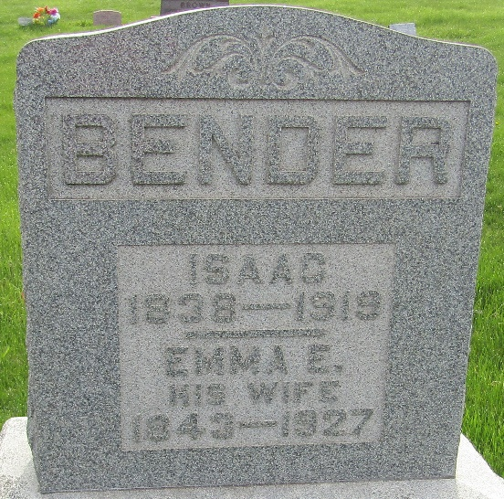

Isaac Bender
in the Indiana, U.S., Death Certificates, 1899-2017
Name Isaac Bender
Gender Male
Race White
Marital Status Married
Age 80
Birth Date June 15, 1838
Birth Place Indiana
Death Date 2 May 1919
Death Place Lancaster, Wells, Indiana, USA
Death Registration Date 1919
Father Jesse Bender
Mother Lash
Spouse Emily E Myers
Informant Can't read
Burial May 4, 1919; Murray Cemetery

**
Isaac B. Bender from tree Mazza Family Tree
Birth 16 Jun 1838 Lawrence, Tuscarawas, Ohio, USA
Marriage 30 Dec 1861 Wells, Indiana, USA
Residence 1910 Wells, Indiana, USA
Death 2 May 1919 Bluffton, Wells, Indiana, USA
Father Jesse Bender (1812-1871)
Mother Catherine Lash (1816-1893)
Spouse Emma Emily "Emily" Myers (1843-1927)

