Emma E. (Myers) Bender
August 29, 1843 – July 12, 1927

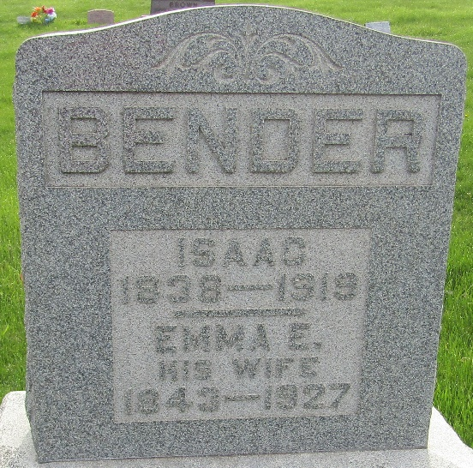

Emily Myers Bender
in the Indiana, U.S., Death Certificates, 1899-2017
Name Emily Myers Bender
[Emily Myers]
Gender Female
Race White
Marital Status Widow
Age 83
Birth Date 29 Aug 1843
Birth Place Richland County, Ohio
Death Date 12 Jul 1927
Death Place Lancaster, Wells, Indiana, USA
Death Registration Date 1926-1927
Father David Myers
Mother Elizabeth Aungst
Spouse Isaac Bender
Informant Fran Bender; Tocsin, Indiana
Burial July 14, 1927; Murray Cemetery

