Cherylynne L (Macon) Baumgartner
December 28, 1950 – August 24, 2011

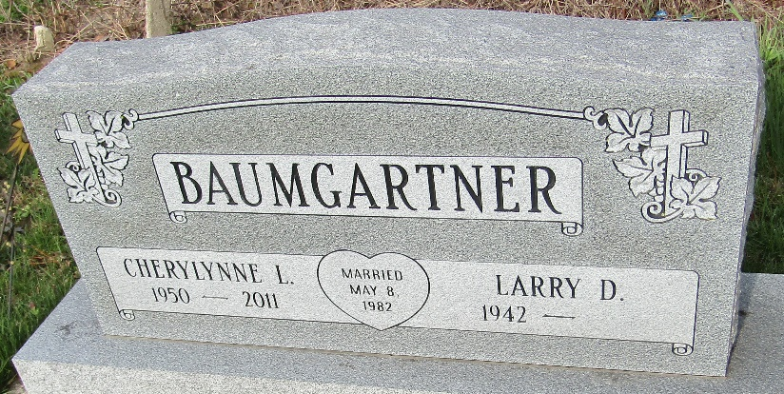

Cherylynne L. Baumgartner went to be with her lord at 4:48 am Wednesday, August 24th, at Bluffton Regional Hospital. Mrs. Baumgartner, age 60, was born December 28, 1950, to Donald and Margaret (Stewart) Macon, who have preceded her in death.
She worked at Wayne Feeds in Fort Wayne and Pretzels in Bluffton. She was graduate of Norwell High School, class of 1969, and a homemaker and grandmother. Cherylynne married Larry D. "Bummie" Baumgartner in Kentucky, on May 8, 1982.
She loved cooking and baking, especially strawberry pie, and loved the Christmas season and celebrating with friends and family.
Survivors include: 1 daughter: Mrs. Cherity (Carl) Ross, Fort Wayne. Sister: Madonna (John) Craig, Mesa, AZ. 2 Brothers: Vaughn (Marlene) Macon, Bluffton, and Steve (Cathy) Macon, Casa Grande, AZ. Along with grandchildren, Tanner, and Chloe Ross. She was preceded in death by a brother, Michael Macon in 2007.
Visitation will be on Monday, August 29th from 2-8pm at Goodwin Memorial Chapel, with service on Tuesday August 30th, at 10:00 am, with Pastor Neil Ainslie. Burial will be at Murray Cemetery, in Wells Co.
Memorials may be made to: Donor's choice.

Goodwin Funeral Home, Wells County, Indiana
August 25, 2011

