Silas W. Ball
March 28, 1878 – March 16, 1879

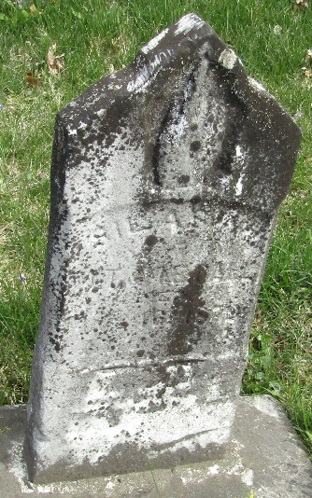

Silas W Ball from tree CHANDLER - HOLT Family Tree
Birth 28 Mar 1878
Death 16 Mar 1879
Father Moses Trader Ball (1853-1945)
Record information.
Mother Mary Elizabeth Shell (1857-1931)
131344 People 1 Record 1 Source

