Jacob William Baker
February 7, 1819 – October 21, 1877

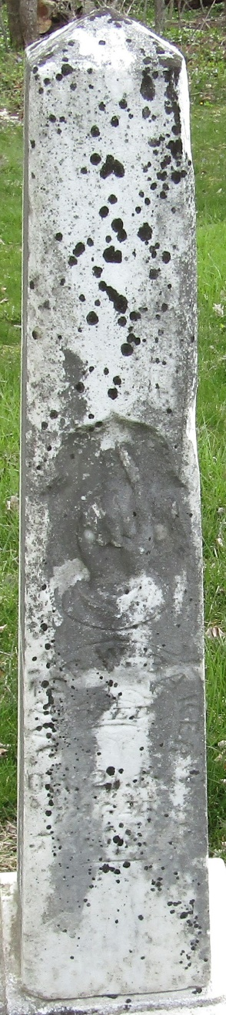

Jacob William Baker in Hall Family Tree
Spouse Harriet King
Father John Adam Baker
Mother Susanna Maurer or Mawry
Children John King
Birth 7 Feb 1819 Somerset, Somerset, Pennsylvania, USA
Death 21 Oct 1877 Bluffton, Wells, Indiana, USA
Residence 1860 Clinton, Indiana, US

