Harriet (King) Baker
May 10, 1826 – March 18, 1873

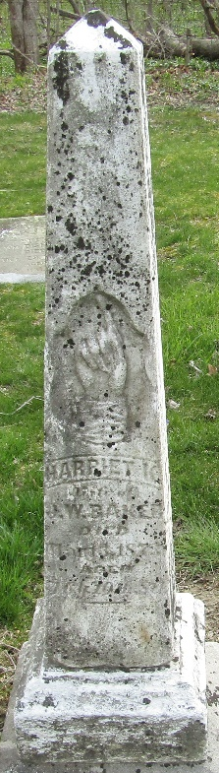

Her father, John T. King, died Dec. 7, 1871. On Sept. 11, 1873 the administrator filed in Somerset Co., PA, a petition, stating that John died leaving a widow and issue 6 children... "Harriet intermarried with Jacob Bender, the said Harriet is also dead leaving 2 children named Minerva and John, both minors under the guardianship of Solomon Pile.”
**
Harriet King in Our Family Tree
Spouse Jacob William Baker
Father John Tanner King
Mother Sarah Boucher
Children Minerva Susanna
Birth 10 May 1826 Somerset, Somerset, Pennsylvania, USA
Death 18 Mar 1873 Bluffton, Wells, Indiana, USA
Residence 1850 Sullivan, Tioga, Pennsylvania, USA

