Fannie (Bricker) Bailey
August 25, 1869 – April 4, 1945

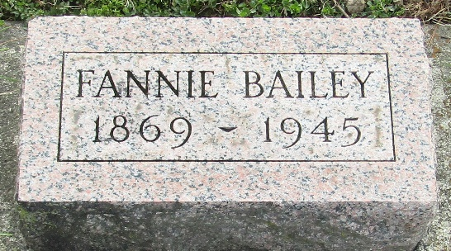

Mrs Fannie Bailey
in the Indiana, U.S., Death Certificates, 1899-2017
Name Mrs Fannie Bailey
[Mrs Fannie Bricker]
Gender Female
Race White
Marital Status Married
Age 75
Birth Date 25 Aug 1869
Birth Place Wells County
Death Date 4 Apr 1945
Death Place Bluffton, Wells, Indiana, USA
Death Registration Date 1945
Father Jacob Bricker
Mother Nellie Mann
Spouse John Bailey
Informant John Bailey
Burial April 7, 1945; Murray Cemetery; Wells County

