Eve (Henline) Arnold
March 19, 1830 – January 19, 1855

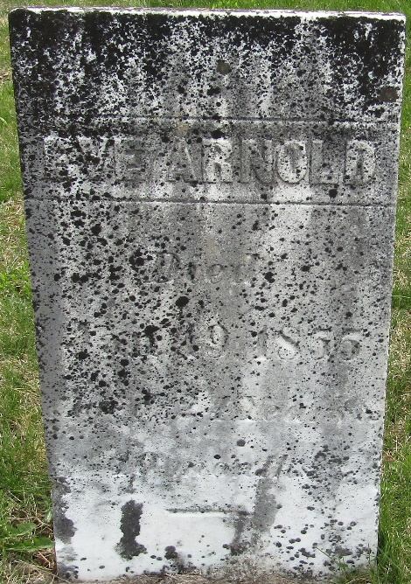

Eve Henline from tree Baird Family Tree
Birth 19 Mar 1830 Jefferson, Richland, Ohio, USA
Residence 1850 Wells, Indiana, USA
Marriage 18 Jun 1854 Wells, York, Maine, USA
Death 19 Jan 1855 Wells, Indiana, USA
Father David Henline (1783-1855)
Mother Catherine Yerger (1786-1857)
Spouse Amos Wilson Arnold (1822-1855)

