David Arnold
1852 – March 11, 1855

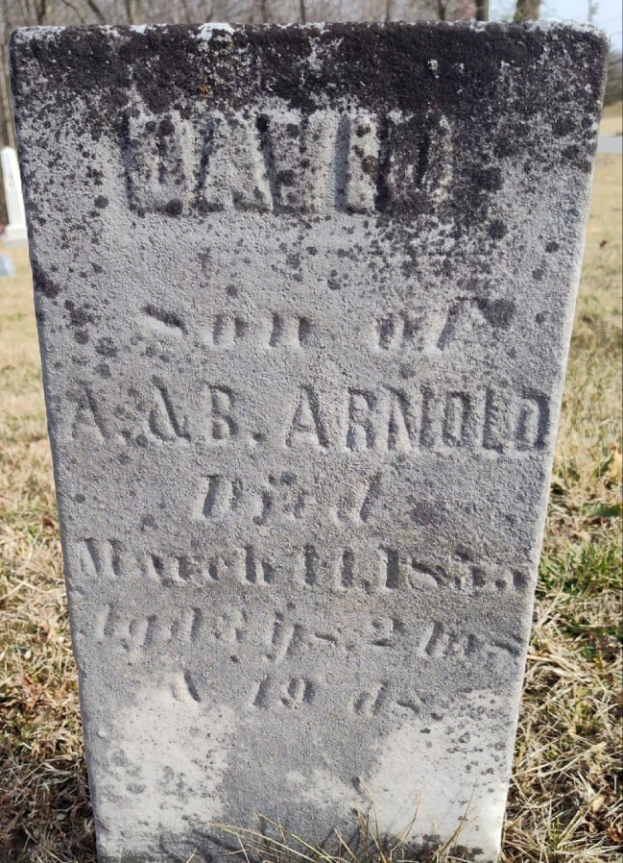
Photo by Colleen Sanders

David ARNOLD from tree Stover M

Birth 1852 Wells, Indiana, USA
Death 11 Mar 1855 Wells, Indiana, USA
Father Amos Wilson ARNOLD (1822-1855)
Mother Barbara Henaline (1827-1853)

