Barbara (Henline) Arnold
September 24, 1827 – August 29, 1853

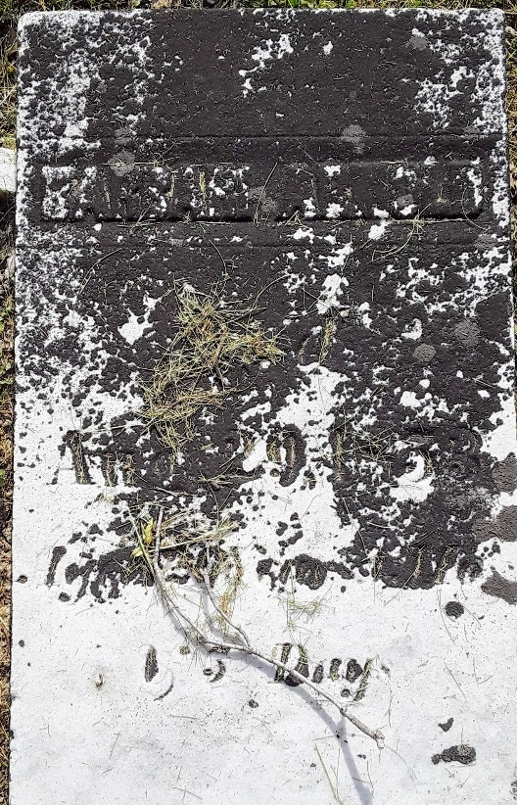

Barbara Henline from tree Hineline family tree
Birth 24 Jul (or Sept) 1827 Ohio, USA
Marriage 1849
Death 29 Aug 1853
Father David Henline (1783-1855)
Mother Catherine Yarger (1786-1857)
Spouse Amos Arnold (1822-1855)

