Amos Wilson Arnold
September 10, 1822 – September 11, 1855

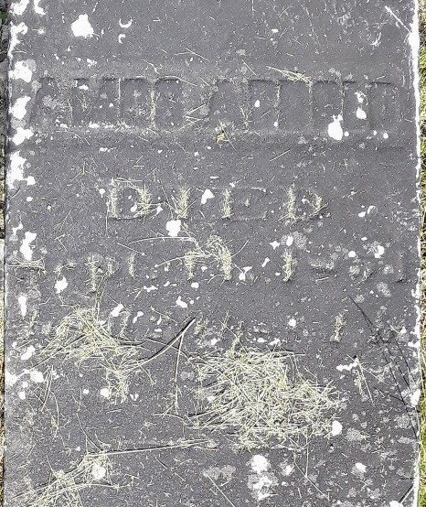

Amos Wilson ARNOLD from tree Stover M
Birth 10 Sep 1822 England
Residence 1850 Wells, Indiana, USA
Marriage 18 Jun 1854 Wells, Indiana, USA
Death 11 Sep 1855 Wells, Indiana, USA
Spouse Eva HENLINE (1830-1855)

