Van Amos
April 19, 1884 – February 26, 1928

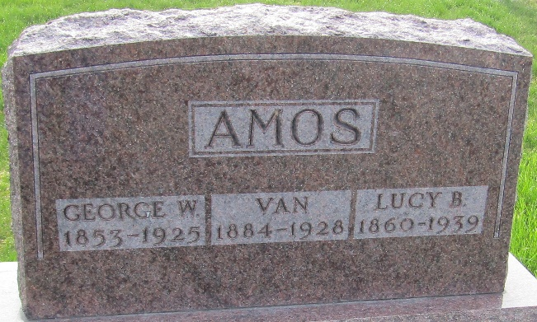

Van Amos
in the Indiana, U.S., Death Certificates, 1899-2017
Name Van Amos
Gender Male
Race White
Marital Status Single
Age 43
Birth Date 19 Apr 1884
Birth Place Indiana
Death Date 26 Feb 1928
Death Place Lancaster, Wells, Indiana, USA
Death Registration Date 1928
Father George W. Amos
Mother Mary McCarty
Informant Mrs. George Amos; Ossian, Indiana
Burial February 28, 1928; Murray Cemetery

