Lucy B. (McCarty) Amos
August 9, 1860 – April 25, 1939

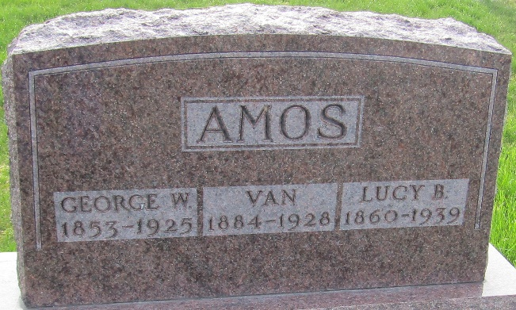

Lucy B. Amos
in the Indiana, U.S., Death Certificates, 1899-2017
Name Lucy B. Amos
[Lucy B. McCarty]
Gender Female
Race White
Marital Status Widow
Age 78
Birth Date 9 Aug 1860
Birth Place Indiana
Death Date 25 Apr 1939
Death Place Kirklin, Clinton, Indiana, USA
Death Registration Date 1939
Father Nathaniel B. McCarty
Mother Edytha I. Pierce
Spouse Geo. W. Amos
Informant J. O. McCarty; Bluffton, Indiana
Burial April 27, 1939; Murray Cemetery

