George W. Amos
February 13, 1853 – April 21, 1925

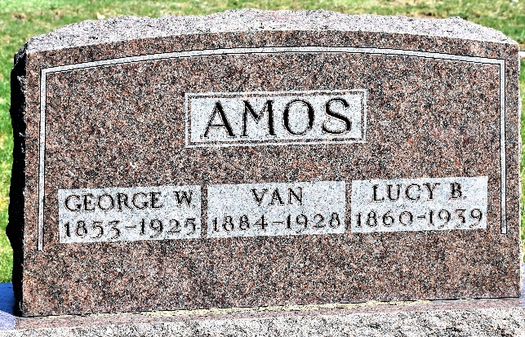
Photo by Colleen Sanders

George W. Amos
in the Indiana, U.S., Death Certificates, 1899-2017
Name George W. Amos
Gender Male
Race White
Marital Status Married
Age 72
Birth Date 13 Feb 1853
Birth Place Indiana
Death Date 21 Apr 1925
Death Place Lancaster, Wells, Indiana, USA
Death Registration Date 1925
Father Asbery Amos
Mother Unknown
Spouse Lucy B
Informant James McCarty; Liberty Center, Indiana
Burial April 24, 1925; Murray Cemetery

**
George W Amos from tree Genette's family tree
Birth 13 Feb 1853 Indiana, USA
Marriage 1876
Residence 1920 Thorncreek, Whitley, Indiana, USA
Death 21 Apr 1925 Wells, Indiana, USA
Father Ashbury Amos (1810-1854)
Mother Mary A "Polly" Laws (1811-1869)
Spouse Lucia Anna B. Amos (Born 1860)

