Sarah (Davis) Aker
October 12, 1811 – July 5, 1887

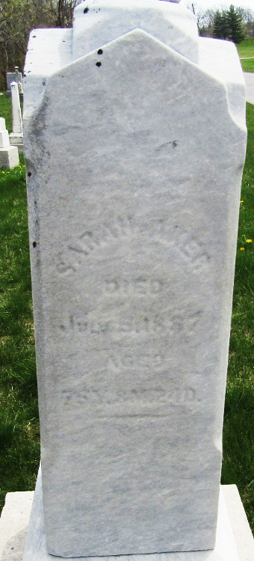

Sarah Davis from tree thomason Family Tree
Birth 12 Oct 1811 Greene, Tennessee, USA
Marriage 22 Aug 1850 Wells, Indiana, USA
Residence 1880 Wells, Indiana, USA
Death 5 Jul 1887 Wells, Indiana, USA
Father George Davis (1782-1865)
Mother Susan Miller (Born 1792)
Spouse David Aker (1811-1888)

