Markus Luvon Aker
December 19, 1914 – January 13, 1915

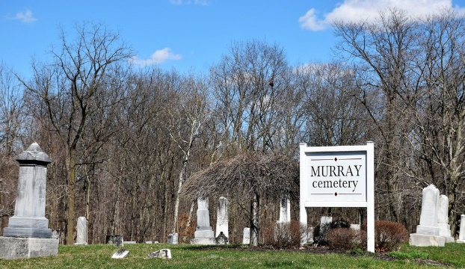
Photo by Colleen Sanders

Markus Luvon Aker
in the Indiana, U.S., Death Certificates, 1899-2017
Name Markus Luvon Aker
Gender Male
Race White
Marital Status Single
Age 24 days
Birth Date 19 Dec 1914
Birth Place Bluffton
Death Date 13 Jan 1915
Death Place Bluffton, Wells, Indiana, USA
Death Registration Date 1910-1919
Father Chas Aker
Mother May L. Faulk
Informant Chas. Aker; Bluffton, Indiana
Burial January 15, 1915; Murray Cemetery

