David Aker
1811 – January 4, 1888

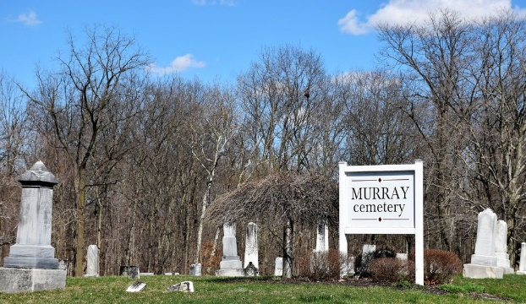
Photo by Colleen Sanders

David Aker from tree Aker Family Tree
Birth 1811 Wythe, Virginia, USA
Marriage 22 Aug 1850 Wells, Indiana, USA
Residence 1880 Wells, Indiana, USA
Death 4 Jan 1888 Bluffton, Wells, Indiana, USA
Father John Aker (1769-1850)
Mother Susanna Dressler (1768-1840)
Spouse Hester Ann Neff
Spouse Sarah Davis Harvey Aker (1812-1887)

