Ruhama (Redding) Abrams
July 23, 1841 – April 9, 1883

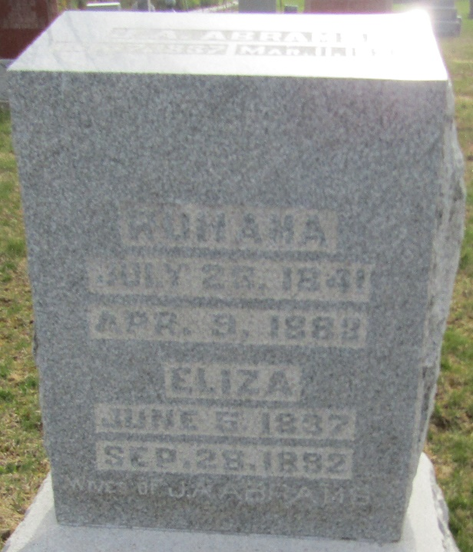

Ruhama Redding in Lehman FTM 2017
Spouse James Anderson Abrams
Father John W. Redding
Mother Mary Ann Bush
Children Grace
Birth 23 Jul 1841 Rush, Indiana, USA
Death 9 Apr 1883 Wells, Indiana, USA
Residence 1880 Wells, Indiana, USA

