James A. Abrams
October 7, 1837 – March 11, 1924

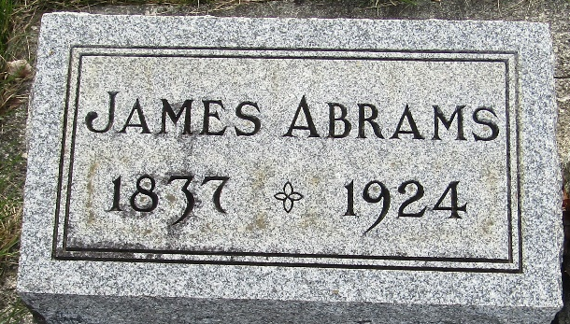

James A Abrams
in the Indiana, U.S., Death Certificates, 1899-2017
Name James A Abrams
Gender Male
Race White
Marital Status Married
Age 86
Birth Date 7 Oct 1837
Birth Place Franklin County, Indiana
Death Date 11 Mar 1924
Death Place Murray, Wells, Indiana, USA
Death Registration Date 1924
Father Noah Abrams
Mother ?? Rose
Mother Rose
Spouse Ellen Redding
Informant Mrs. J. Maybe; Bluffton, Indiana
Burial March 13, 1924; Murray Cemetery

