Eliza Abrams
June 5, 1837 – September 28, 1892

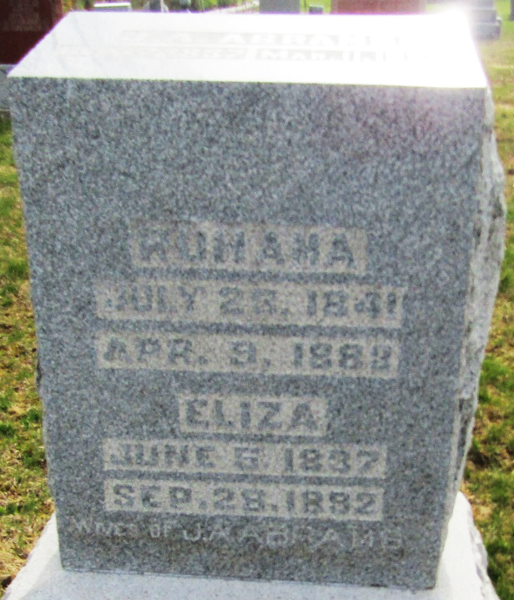

Eliza Abrams from tree Alfred Carlton Sheley and Sallie Marie Purvis
Birth 5 Jun 1837
Marriage 1884 Wells, Indiana, USA
Death 28 Sep 1892 Wells, Indiana, USA
Spouse James Anderson Abrams (1837-1924)
1514 People 1 Record 1 Source

