Benjamin Abrams
January 6, 1872 – November 21, 1914

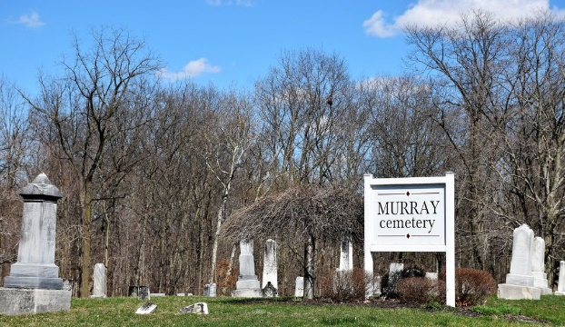
Photo by Colleen Sanders

Victim of Shanty Fire at Kingsland Succumbs to Burns

Benjamin Abrams, who was horribly burned when the shack in which he lived at Kingsland caught fire Friday night, died yesterday noon without regaining consciousness. Abrams was taken to the home of his brother, John Abrams, after he had been rescued from the burning building at which place he died.
No one seems to know how the building caught fire, but it is supposed that a small stove in the house became overheated. Abrams was forty-two years of age.
Surviving, he leaves besides the brother, his parents, Mr. and Mrs. James Abrams, and a sister. Two children are living in Muncie with foster parents.
The funeral will be held Tuesday morning at 10:30 from the Kingsland Methodist Episcopal Church. Burial at the Murray Cemetery.

Journal-Gazette, Allen County, Indiana
November 23, 1914

