William E. Luckey
May 31, 1863 – June 15, 1900

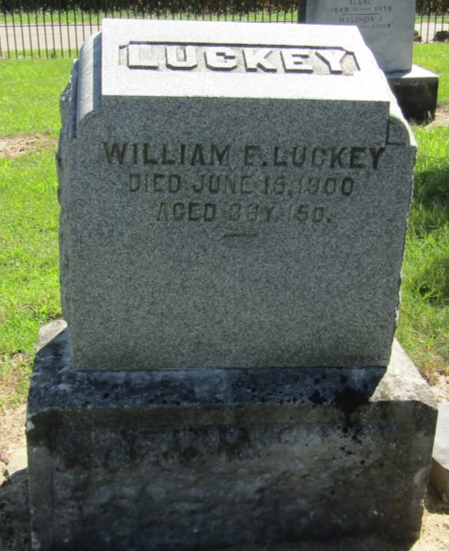

William E Luckey
in the Indiana, Death Certificates, 1899-2011
Name: William E Luckey
Gender: Male
Race: White
Age: 37 years
Marital status: Married
Birth Date: abt 1863
Birth Place: William Luckey
Death Date: 15 Jun 1900
Death Place: Liberty, Wells, Indiana, USA
Father: William Luckey
Mother: Millicent Sexton
Informant: ??; Liberty Center, Indiana
Burial: June 17, 1900; Mossburg Cemetery

