Alfred Bower Lowdermilk
June 15, 1843 – April 15, 1910

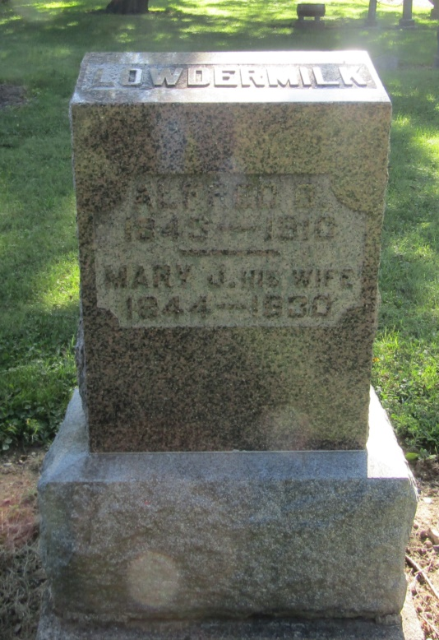

Alfred Bower Landermilk
in the Indiana, Death Certificates, 1899-2011
Name: Alfred Bower Laudermilk
Gender: Male
Race: White
Age: 66
Marital status: Married
Birth Date: 15 Jun 1843
Birth Place: Randolph Co N C
Death Date: 15 Apr 1910
Death Place: Liberty, Wells, Indiana, USA
Father: John Laudermilk
Mother: Cynthia Swaim
Spouse: Mary Jane Cox
Informant: Mrs. A. B. Loudermilk; Liberty Center, Indiana
Burial: April 17, 1910; Mossburg Cemetery

