Leona M. Landis
October 8, 1901 – August 23, 1902

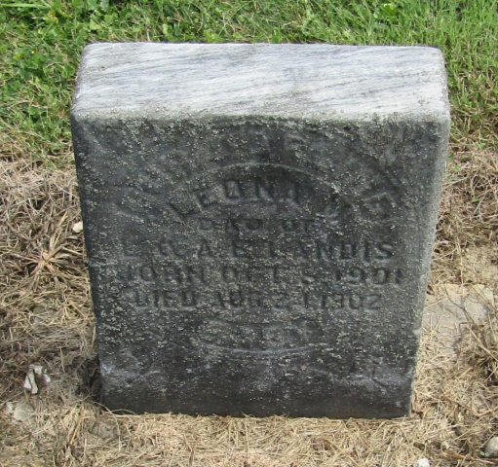

Lona M Landis
in the Indiana, Death Certificates, 1899-2011
Name: Lona M Landis
Gender: Female
Race: White
Age: 10/12
Marital status: Single
Birth Date: 8 Oct 1901
Birth Place: Huntington Co Ind
Death Date: 23 Aug 1902; dysentery
Death Place: Salamonia, Huntington, Indiana , USA
Father: Leander Landis
Mother: Anna Jones
Informant: Mrs. Anna Landis; Buckey, Indiana
Burial: August 25, 1902; Mossburg Cemetery

