Mary Keith
- August 17, 1877

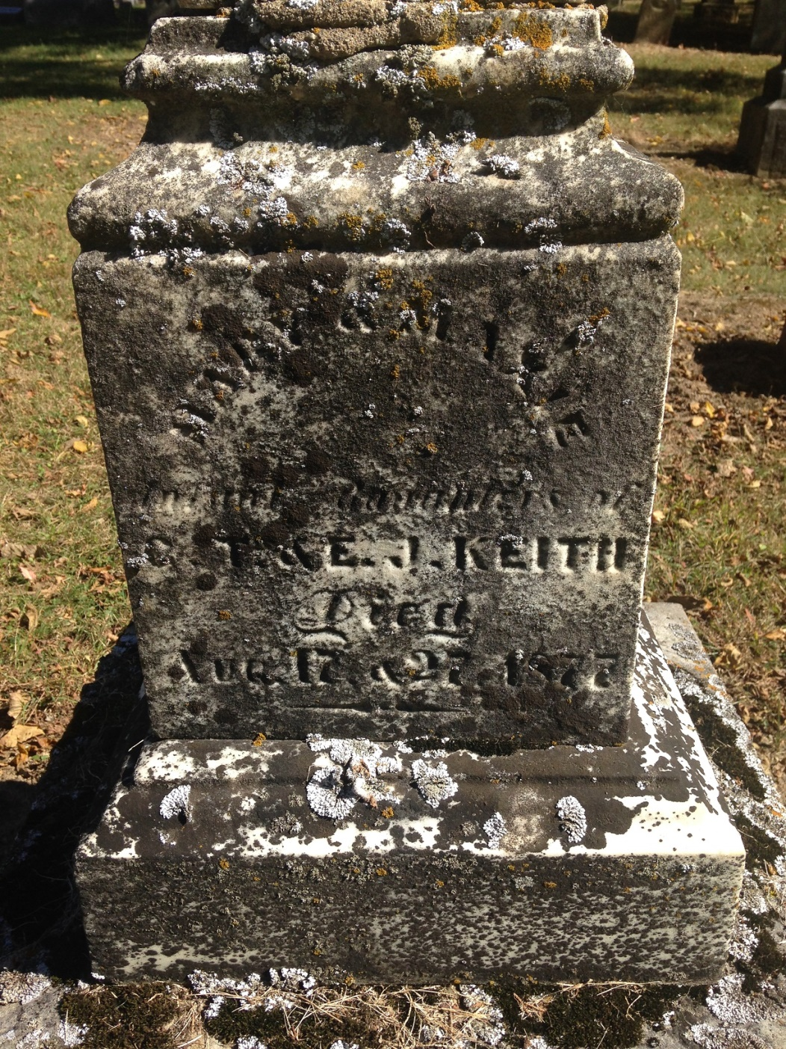
Photo by Barbara Baker Anderson

No further information found at this time

