Loren T. Jones
1897 - 1899

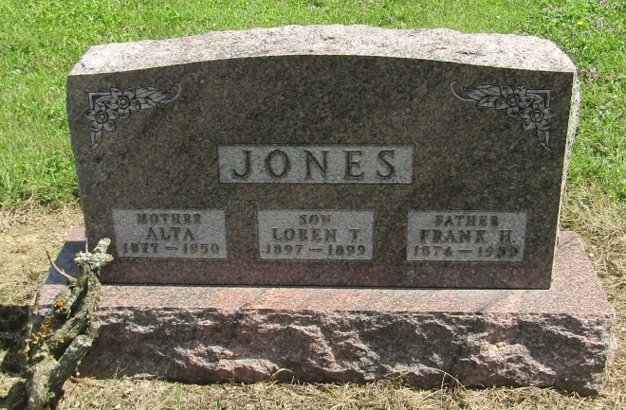

No further information found at this time

