Alta (Thomas) Jones
March 3, 1877 – August 12, 1950

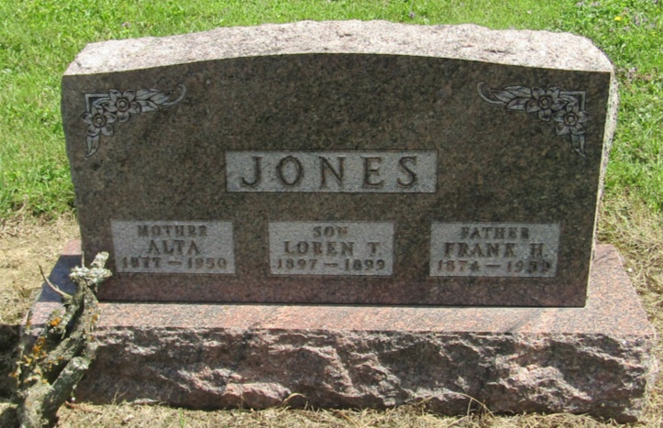

Alta Jones
in the Indiana, Death Certificates, 1899-2011
Name: Alta Jones
[Alta Thomas]
Gender: Female
Race: White
Age: 73
Marital status: Married
Birth Date: 3 Mar 1877
Birth Place: Indiana
Death Date: 12 Aug 1950
Death Place: Fort Wayne, Allen, Indiana , USA
Father: Lafayette Thomas
Mother: Margaret Silver
Informant: Frank H. Jones; Fort Wayne, Indiana
Burial: August 15, 1950; Mossburg Cemetery; Wells County, Indiana

