Xenon Milton Johnson
August 25, 1845 – November 4, 1889

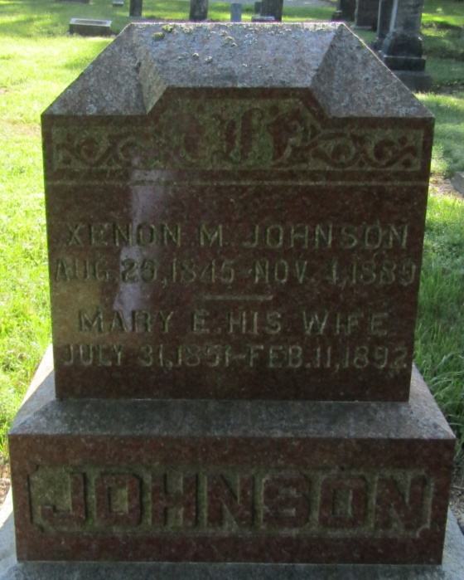

Liberty Center Indiana, November 8, 1889
Deacon X. M. Johnson after several weeks’ illness departed this life Nov. 4, 1889. The deceased had been gradually improving for ten days and was thought much better on the morning of the 4th, at 9 o'clock he took suddenly worse and passed away at five o'clock.
He was born in Ohio, August, 25, 1845 and came to this community with his parents in 1853 where he has ever since resided. He was married to Elizabeth Ernst, December 23rd, 1868. The fruit of this union was eight children, six of whom remain to mourn the loss.
He united with the Liberty Center Baptist Church in the winter of 1868 and was baptized by his father Elder Abel Johnson who still lives there. He has ever since lived a consistent and exemplary Christian life. He was indeed a pillar of the church which elected and ordained him one of her deacons in 1875, the duties of which office he faithfully discharged.
At the time of his death he was 44 years, 2 months and 9 days of age. Thus another; an obedient son, a loving husband, and a faithful officer, has been called home to his reward and has joined that innumerable throng before the throne.
The writer stood by his side the last few hours of his life and there witnessed the sublimest trust and confidence in God, which amounted to the most perfect assurance. He died without a struggle to join in the glorious triumphs of a living and abiding faith. May we all thus die, is the prayer of his mourning pastor.
The funeral occurred Nov. 6 from the church conducted by his pastor Rev. J. W. Porter assisted by Rev. D. R. McGregor in the presence of a very audience of friends and neighbors.

Bluffton Chronicle, Wells County, Indiana
November 14, 1889

