Emma Jane (Mossburg) Johnson
March 28, 1889 – October 10, 1963

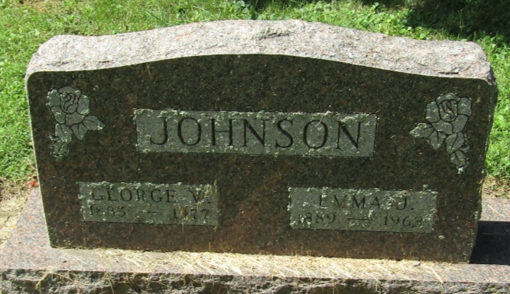

Emma Jane Johnson
in the Indiana, Death Certificates, 1899-2011
Name: Emma Jane Johnson
[Emma Jane Mossburg]
Gender: Female
Race: White
Age: 74
Marital status: Married
Birth Date: 28 Mar 1889
Birth Place: Liberty Twp Wells Co
Death Date: 10 Oct 1963
Death Place: Liberty Center, Wells, Indiana , USA
Father: Hiram Mossburg
Mother: Hanna First
Informant: George W. Johnson; husband; Liberty Center, Indiana
Burial: October 12, 1963; Mossburg Cemetery; Wells County, Indiana

