Charles Bert Johnson
October 10, 1872 – September 11, 1893

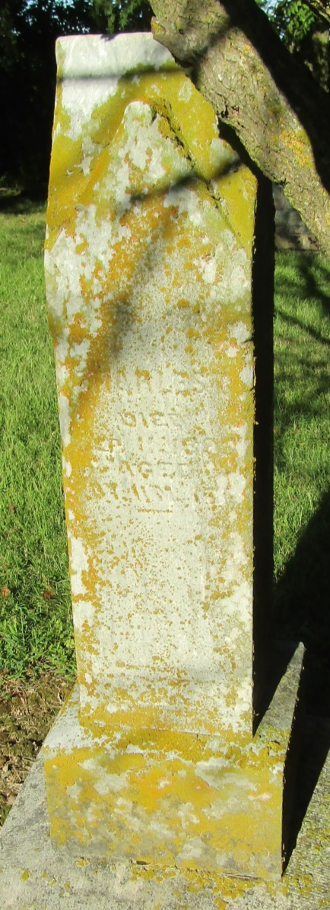

Up to this date there have been twenty cases of typhoid fever in this village, three deaths out of the twenty cases and some at this time are beyond hopes of being any better.
The persons who met death with this disease were Burt and Otto Johnson, sons of A. J. Johnson, age 20 and 12 years and a little girl of Henry and Sarah C. Ladd, age 7 years.

Bluffton Banner; Wells County, Indiana
A weekly newspaper
Wednesday, September 20, 1893

