Bentley B. Jarrett
February 14, 1922 – July 15, 1974

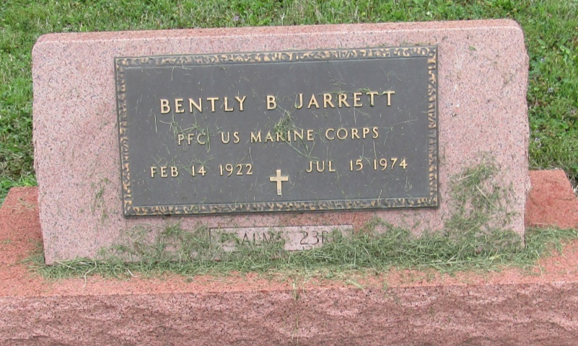

Bentley B Jarrett
in the Indiana, Death Certificates, 1899-2011
Name: Bentley B Jarrett
Gender: Male
Race: White
Age: 52
Birth Date: 14 Feb 1922
Birth Place: Ind
Death Date: 15 Jul 1974
Death Place: Ft Wayne, Allen, Indiana, USA
Father: William Jarrett
Mother: Susan Gregg
Informant: Eric N. Jarrett; son; Liberty Center, Indiana
Removal: July 18, 1974; Mossburg Cemetery; Bluffton, Indiana

