Ronald Ivins
August 22, 1941 – August 22, 1941

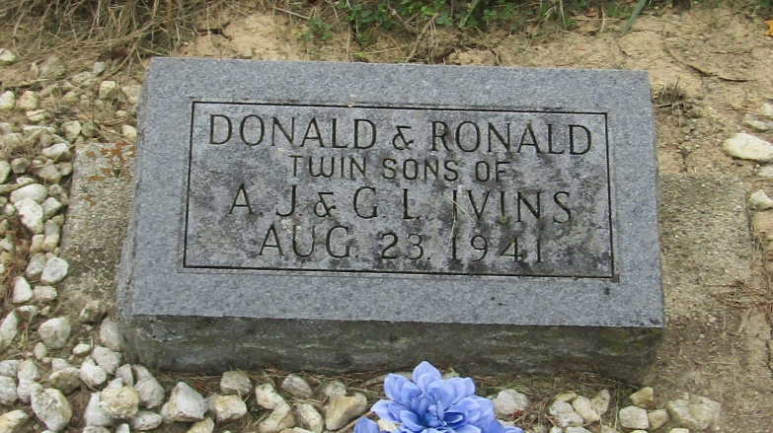

TWIN SONS BORN AT HOSPITAL DIE
PARENTS, MR. AND MRS. ARNOLD IVINS; FIVE BROTHERS, SISTERS SURVIVE
Twin sons born about 11 p. m. Friday at the Wells county hospital to Arnold and Gladys Haughten Ivins, of Pleasant View, died shortly after birth.
Surviving besides the parents are five brothers and sisters, Edson, Lucille, Virginia, Kay and Ivan Ivins, all at home.
Funeral services will be held at 2:30 this afternoon at the Jahn Funeral Home with burial in the Mossburg Cemetery.

Evening News-Banner, Wells County, Indiana
August 25, 1941

*****
Indiana, Death Certificates, 1899-2011
Name: Ronald Ivins
Gender: Male
Race: White
Age: 1 hour, 5 minutes
Marital status: Single
Birth Date: 22 Aug 1941
Birth Place: Bluffton, Wells Co Indiana
Death Date: 22 Aug 1941
Death Place: Bluffton, Wells, Indiana, USA
Father: Arnold Ivins
Mother: Gladys Haughton
Burial: August 24, 1941; Mossburg Cemetery; Liberty Center, Indiana

