Arnold John Ivins
July 2, 1907 – November 22, 1983

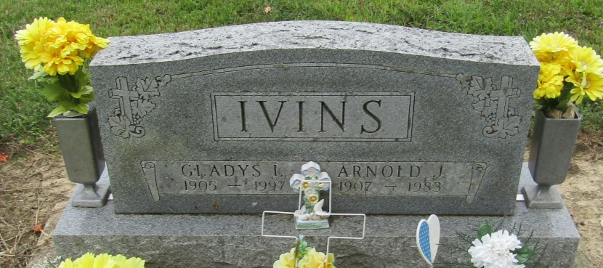

Arnold Ivins
in the Indiana, Death Certificates, 1899-2011
Name: Arnold Ivins
Gender: Male
Race: White
Age: 76
Marital status: Married
Birth Date: 2 Jul 1907
Birth Place: Illinois
Death Date: 22 Nov 1983
Death Place: Bluffton, Wells, Indiana, USA
Father: Harvey Ivins
Mother: Emma Lautzenheiser
Spouse: Gladys L. Haughton
Informant: Gladys Ivins; Linn Grove, Indiana
Burial: November 25, 1983; Mossburg Cemetery; Wells County, Indiana

